Sandip Maity
Roll NO: UG/SOET/165/23/082
Unstructured Database lab 2 Date: 19.01.2026
Q1. Create schema (collection structure) and insert 6 documents
use college
db.students.insertMany([
{
Roll_no: 1,
Name: "Ram",
Age: 20,
Salary: 546.7,
City: "A",
Phone_no: 123
},
{
Roll_no: 2,
Name: "Alex",
Age: 19,
Salary: 333.4,
City: "B",
Phone_no: 456
},
{
Roll_no: 3,
Name: "John",
Age: 40,
Salary: 666.7,
City: "C",
Phone_no: 122
},
{
Roll_no: 4,
Name: "Bob",
Age: 55,
Salary: 678.4,
City: "D",
Phone_no: 444
},
{
Roll_no: 5,
Name: "Mukesh",
Age: 30,
Salary: 245.6,
City: "E",
Phone_no: 567
},
{
Roll_no: 6,
Name: "Danny",
Age: 28,
Salary: 546.3,
City: "F",
Phone_no: 892
}
])
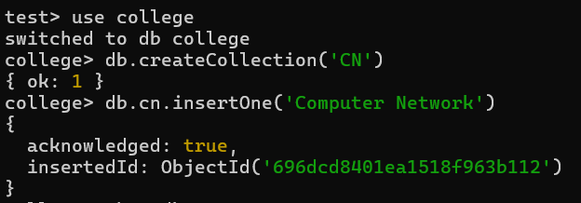
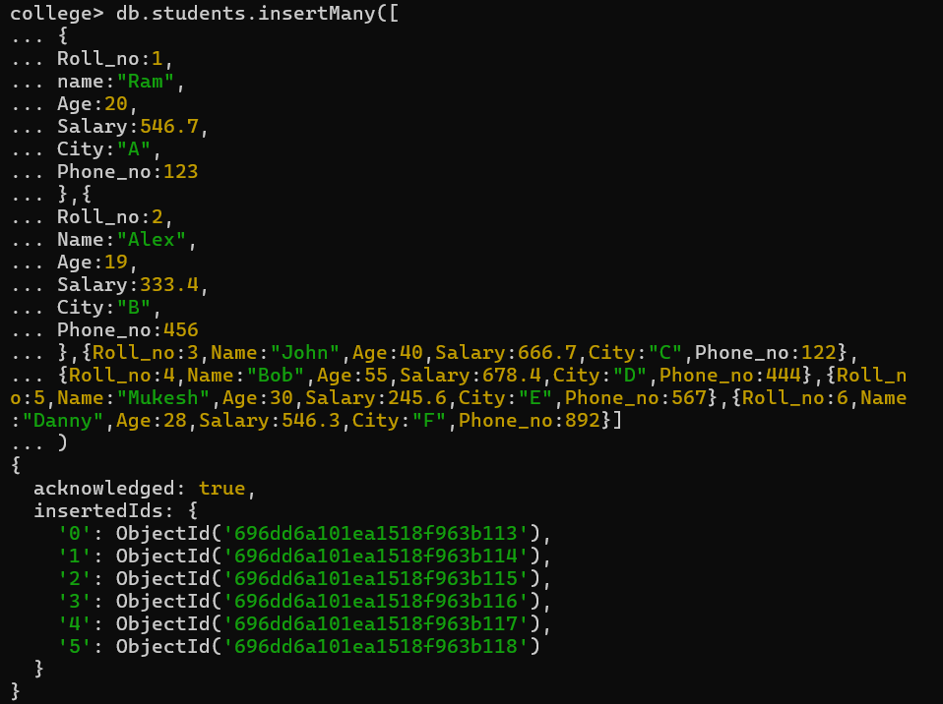

Q2. Update the name of RAM to SAM

db.students.updateOne(
{ Name: "Ram" },
{ $set: { Name: "Sam" } }
)
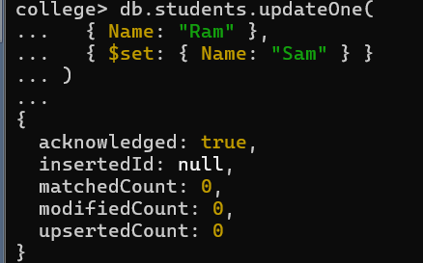

Q3. Display only the cities present in the collection
db.students.find(
{},
{ _id: 0, City: 1 }
)
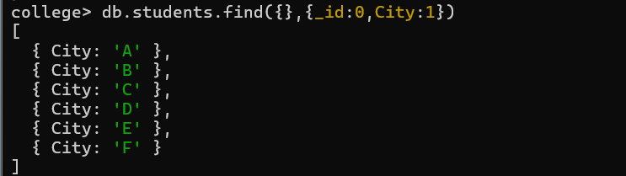

Q4. Update the salary by 10%
db.students.updateMany(
{},
{ $mul: { Salary: 1.10 } }
)
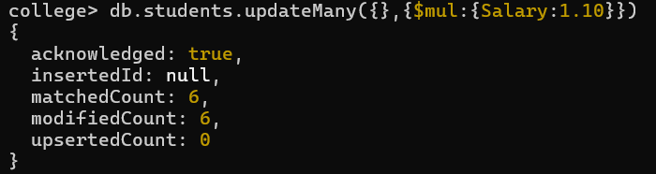

Q5. Display all documents in ascending and descending order of age
Ascending order

db.students.find().sort({ Age: 1 })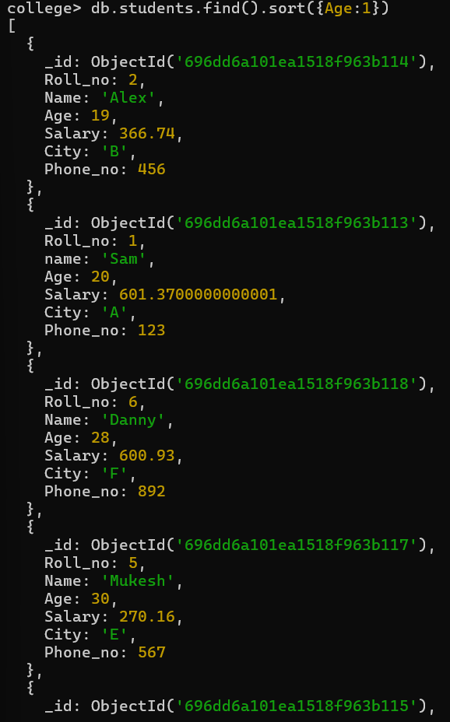

Descending order

db.students.find().sort({ Age: -1 })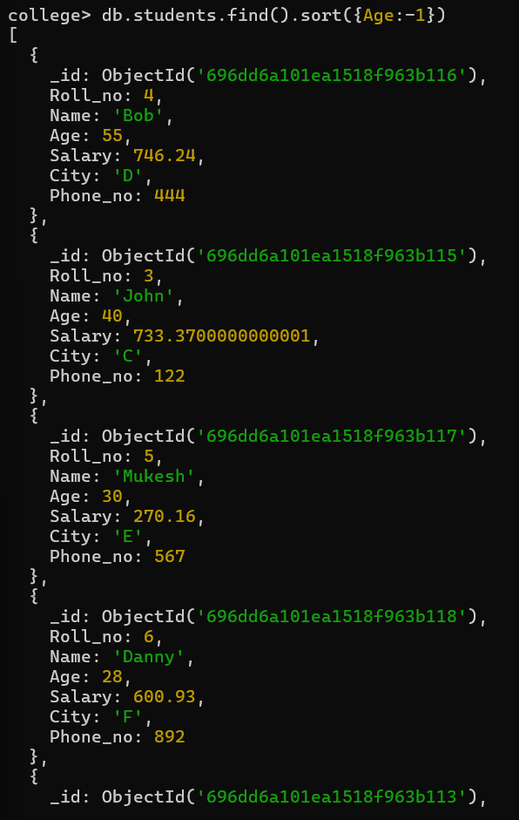

Q6. Display all documents with City → A, B, C
db.students.find(
{ City: { $in: ["A", "B", "C"] } }
)
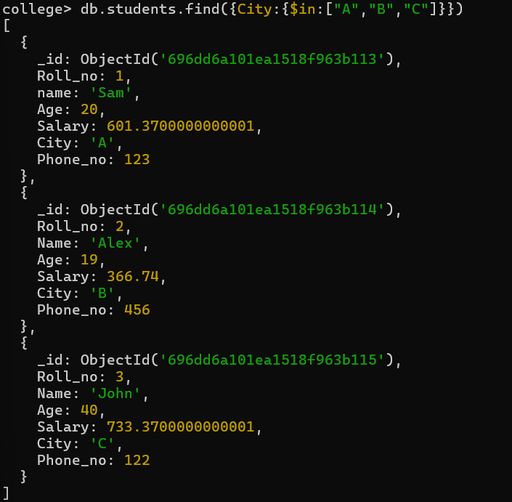

Q7. Display only two documents from the collection
db.students.find().limit(2)
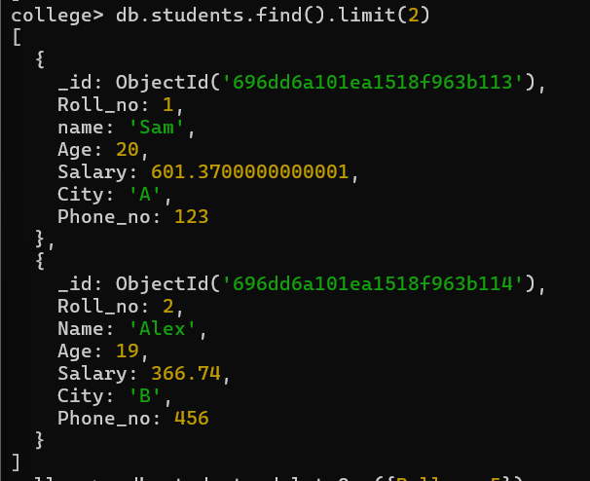
Q8. Delete a document with ROLL_NO = 5
db.students.deleteOne({ Roll_no: 5 })

Q9. Display all documents with AGE greater than 20
db.students.find({ Age: { $gt: 20 } })
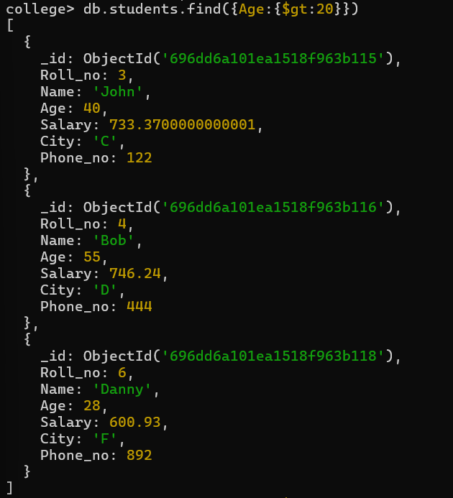

Q10. Display all documents with AGE less than 20
db.students.find({ Age: { $lt: 20 } })
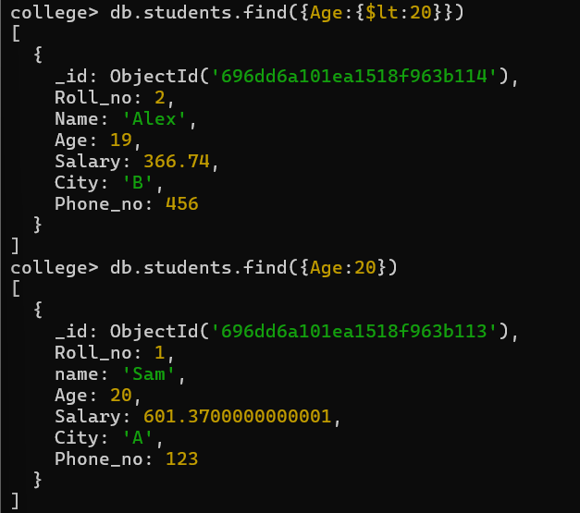

Q11. Display all documents with AGE equals to 20
db.students.find({ Age: 20 })
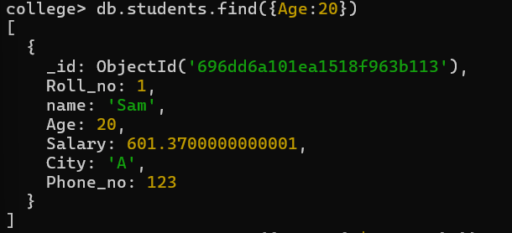
Q12. Display all documents with AGE not equals to 20
db.students.find({ Age: { $ne: 20 } })
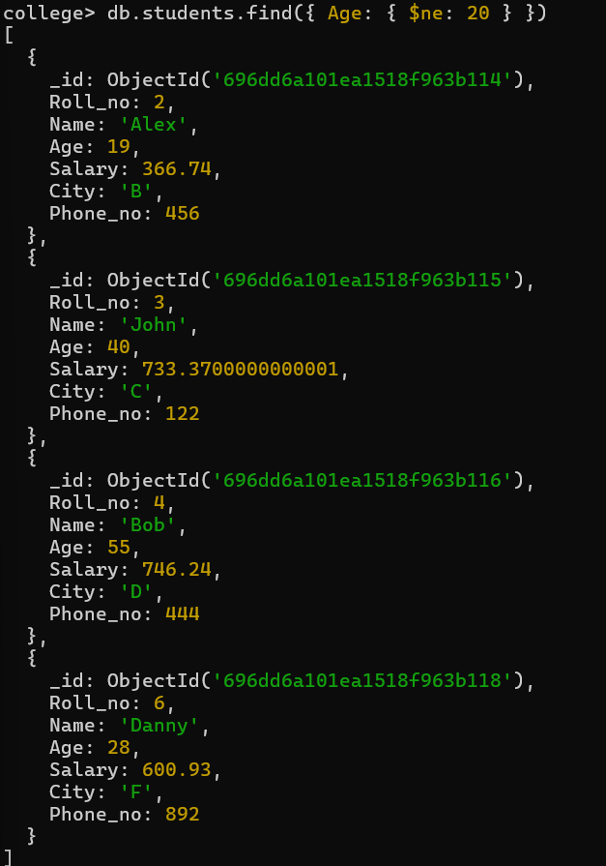

Q13. Display all documents with AGE greater than or equals to 30
db.students.find({ Age: { $gte: 30 } })
